SMART RELOCATIONS WEBSITE SPECIFICATION DOCUMENT
By Pono Patience Martha Sopejame
WEBSITE SPECIFICATIONS
Smart Relocations is a logistics company with an existing website developed and hosted by Host Guru. According to a website data analytics site (Ahrefs, 2026) it is estimated to have a poor online presence, indicated by an organic traffic of 1 person per month. This leads to a conclusion that it is unable to garner customer attraction. To tackle this issue the company has commissioned a project to redesign and redevelop their website. After completion of this project the website should clearly communicate:
- Value proposition offered to the customer by trusting the company with their goods.
- Limitations to extent of service provision to allow customers to be fully informed of what each service involves.
- Contact information for further enquiries to offer customer support.
- History of the company to give customers background information about the organisation they wish to get involved with.
- Platform for customers to provide feedback on services provided or gain insight into past experiences of other customers.

The content goal of this website is for e-commerce activities. It targets manufacturers, small and medium enterprises, and individuals. A deeper analysis of this demography indicates it comprises individuals:
- With businesses located in industrial zones for transportation of finished products from workshops to final consumers, and urban areas mostly with high commercial activity.
- With a steady need for importation and exportation of goods through the service of a middleman.
- With literacy skills and completion of a minimum of basic education.
- In the age range of 24 – 65 years who have the authority to take decisions in an organization.
Users in this demography are considered well-versed with using online platforms. Therefore, design options will be referenced from existing websites which offer similar services to meet user expectations. However, analysis of user experience will be taken and reviewed to confirm and adjust as necessary to enhance customer experience.

INFORMATION DESIGN & TAXONOMY
Site Map

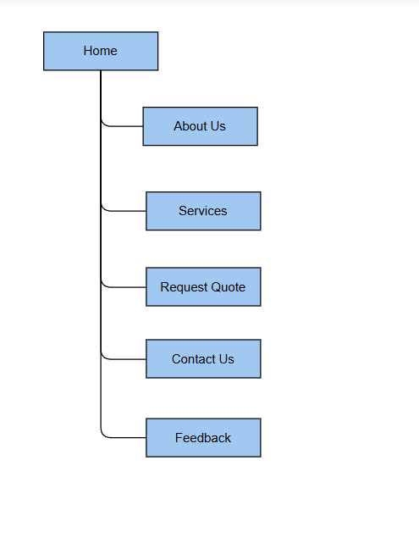

Storyboard Flowchart

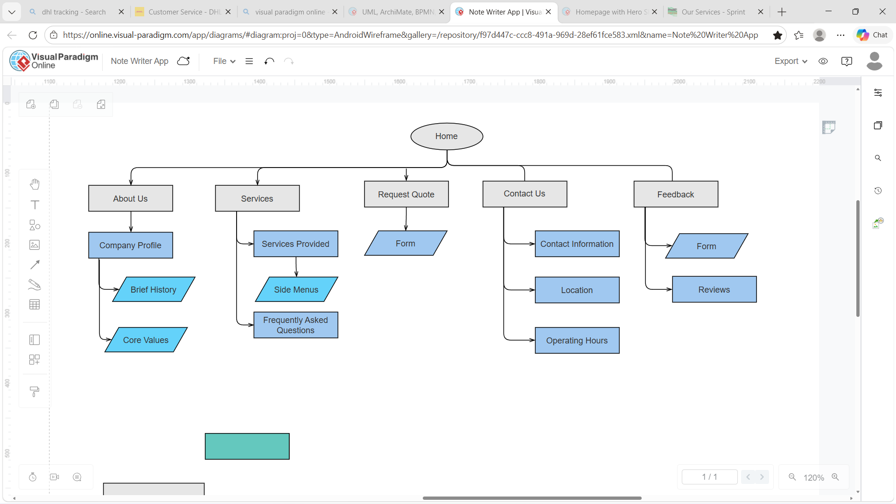

TECHNICAL BRIEF
An HP 15.6inch laptop with an AMD Ryzen 5 processor will be used as the primary device for coding and testing the web pages in this project. Software resources in use will include a GIMP application tool for creation and editing of images, VS Code for coding to construct the site and Bootstrap to allow implementation of CSS throughout the code. The finished project will be hosted on GitHub Pages.

PAGE TEMPLATE DESIGN

This website is designed for use in PIXEL-SIZE displays in nd but considerations will be made for mobile device users

- home.html

Desktop Display
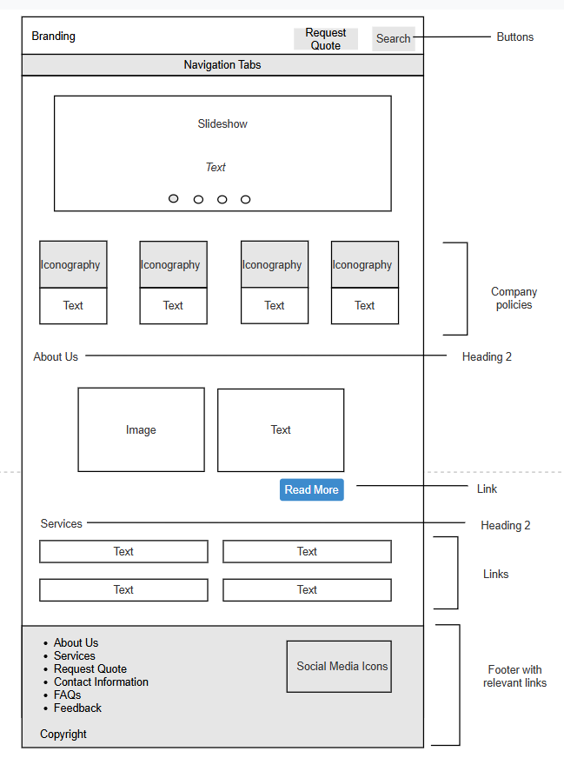

Mobile Phone Display
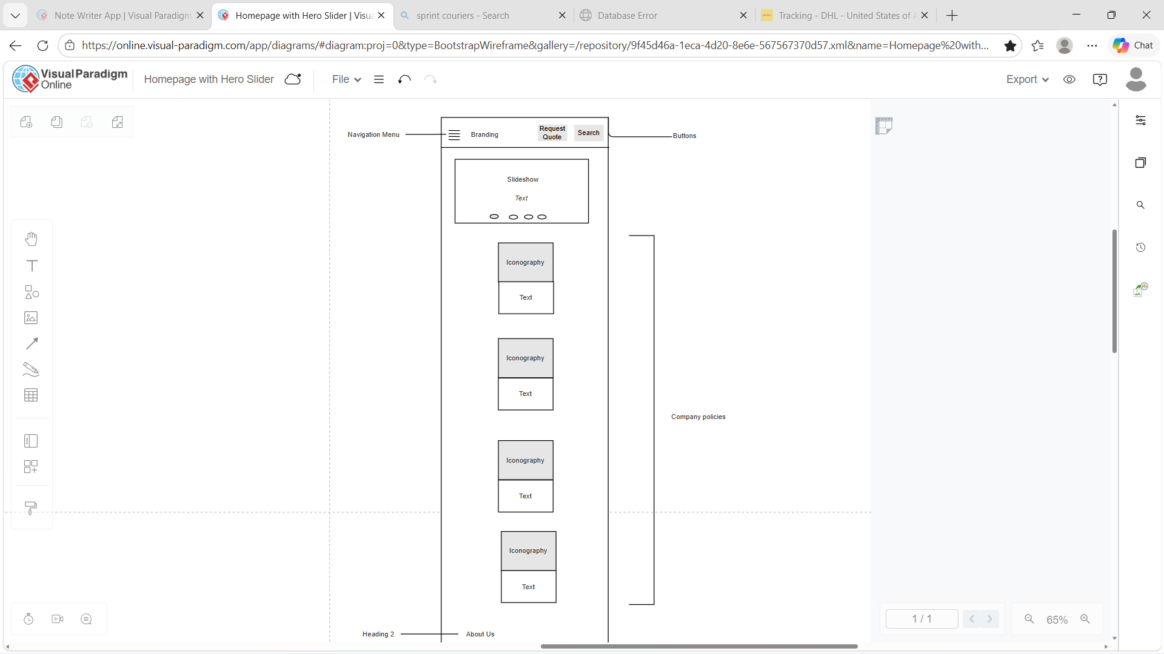
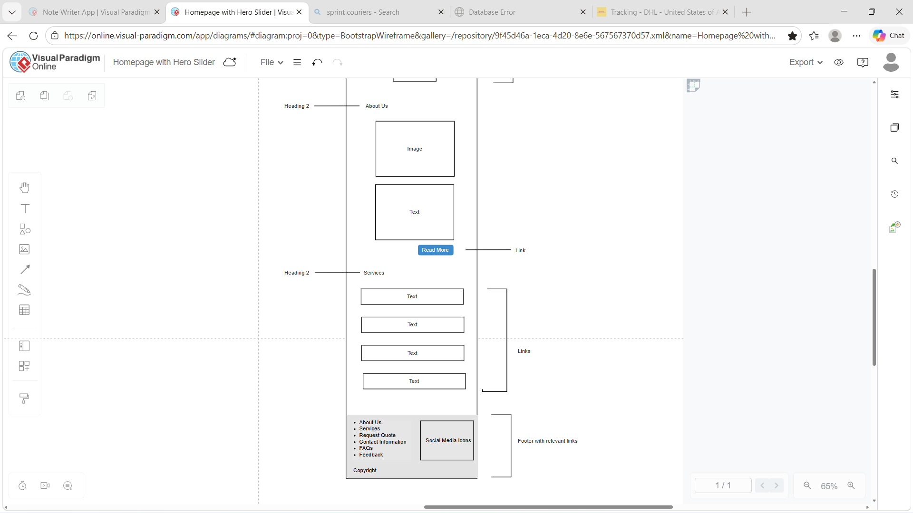

- about-us.html

Desktop Display

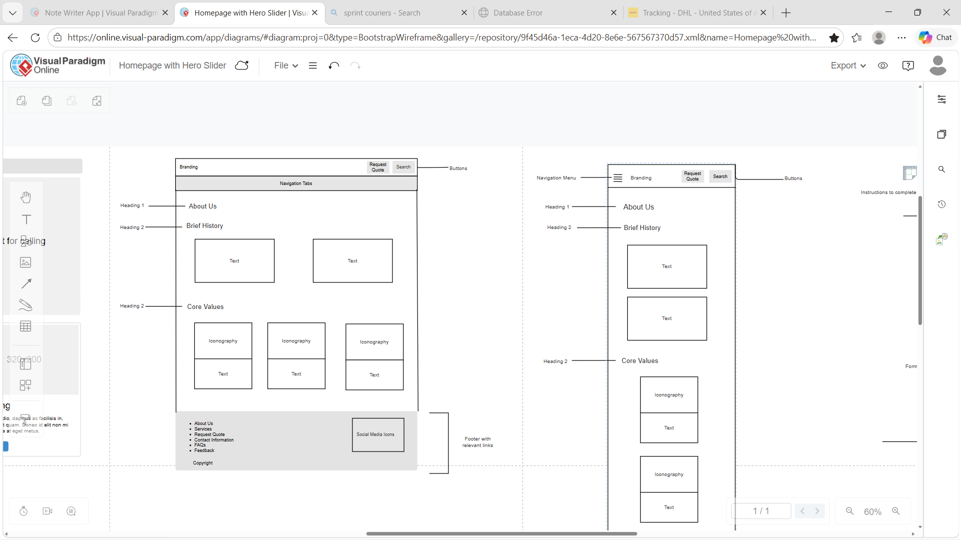

Mobile Phone Display

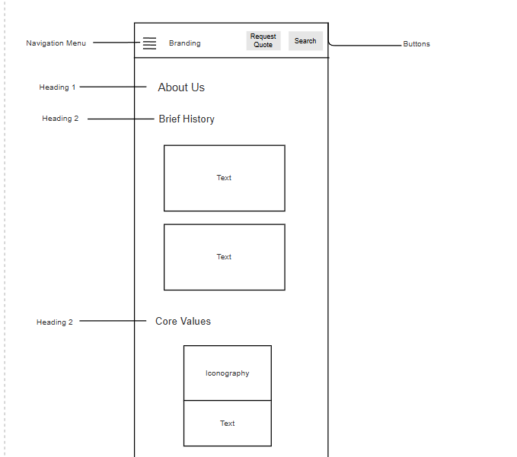
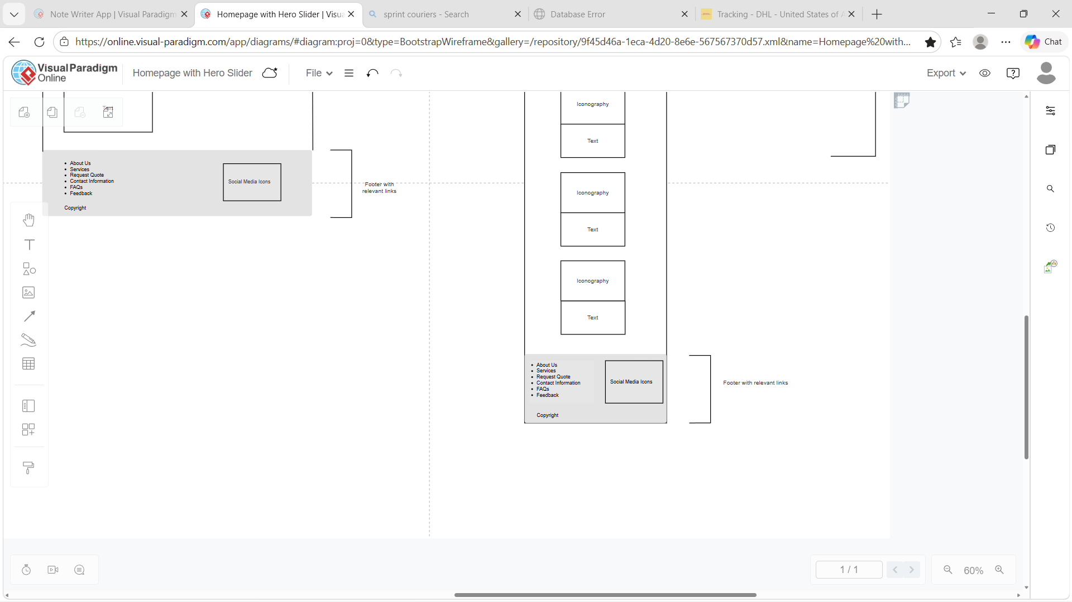

- services.html

Desktop Display
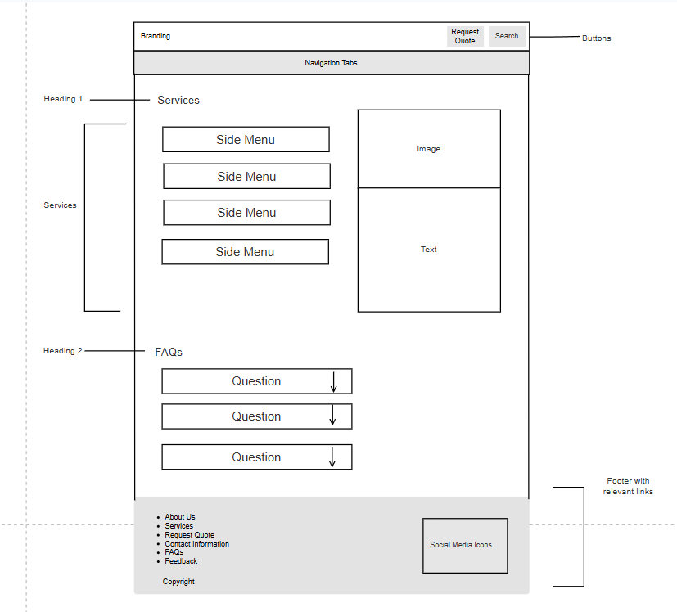

Mobile Phone Display
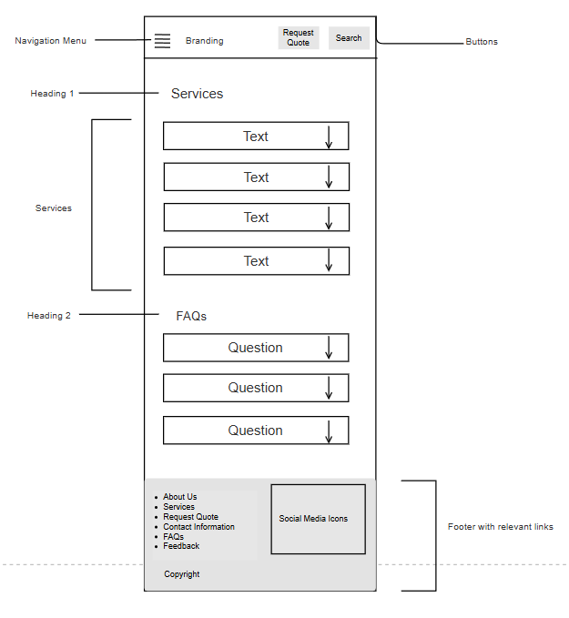

- request-quote.html
Desktop Display
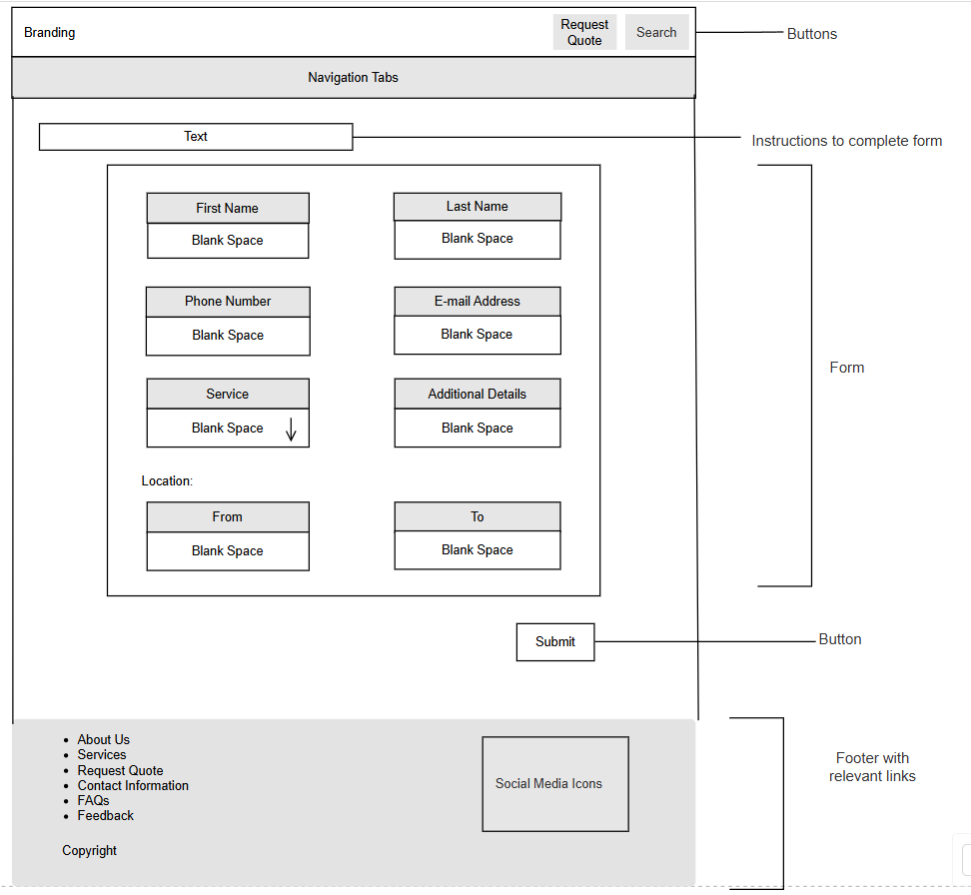

Mobile Phone Display

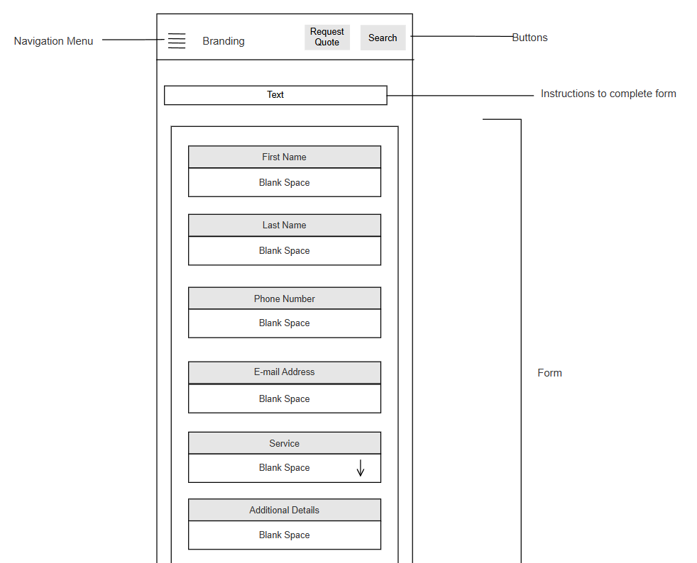
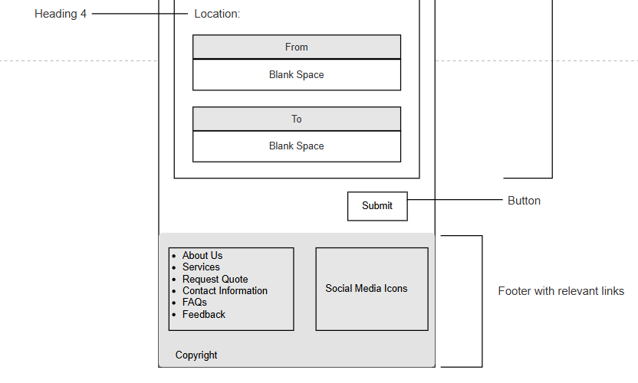

- contact-us.html

Desktop Display

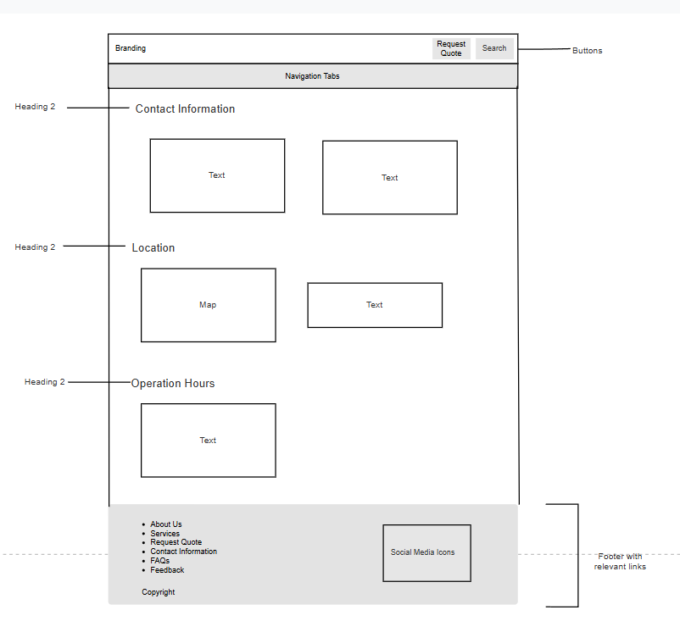

Mobile Phone Display

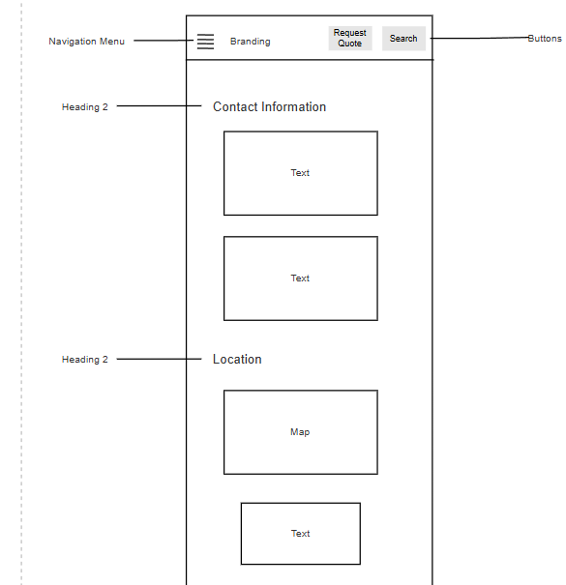
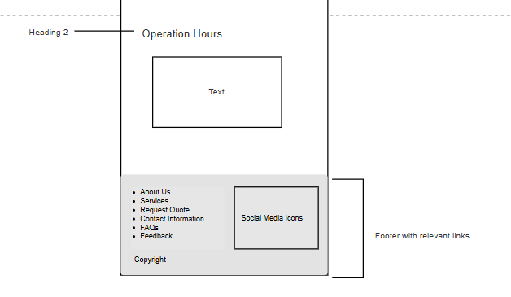

- feedback.html

Desktop Display

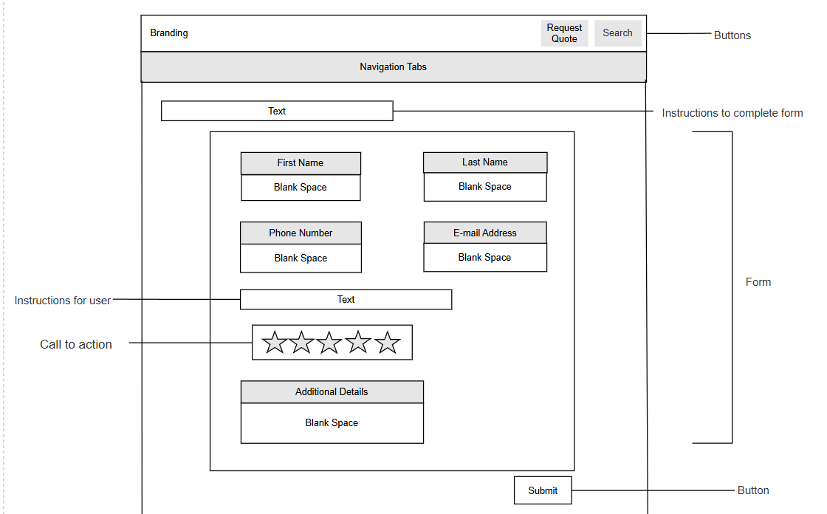
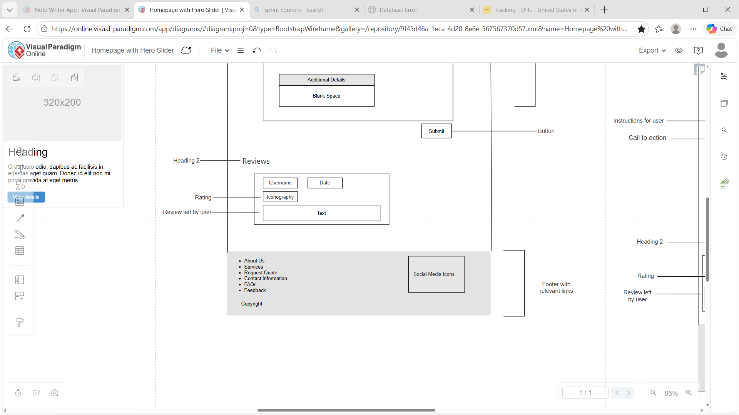
Mobile Phone Display

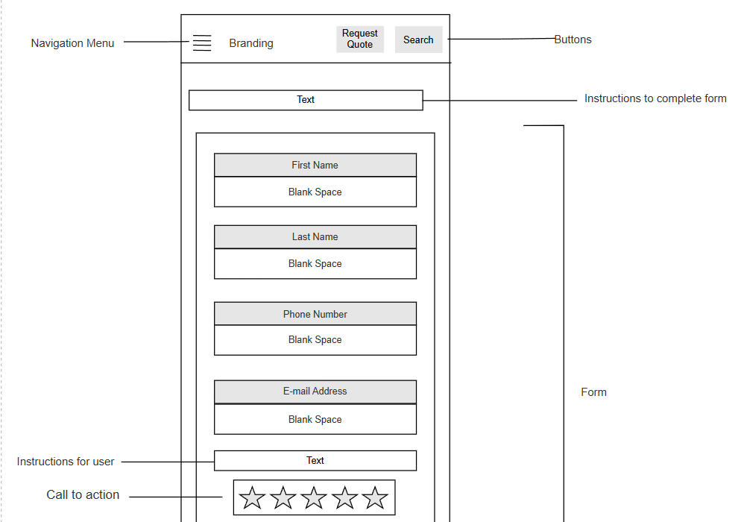
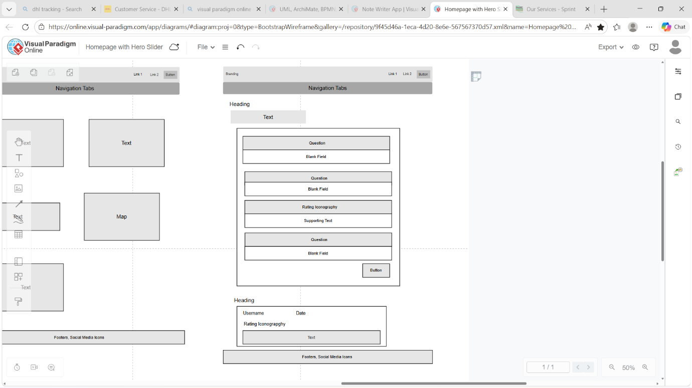

QUALITY ASSURANCE
Testing was done on Windows 11 OS, Android12 (sekgoropa), khumi(recent), boo os version
The image clarity is consistent across all web browsers.(chrome. Safari, firefox,mozilla
Content design appears as depicted in wireframes.

PUBLISHING AND PROMOTION
As referred to above this website will be hosted on github , it will be uploaded through Microsoft Edge browser. It foregoes known GitHub commands as they are moderately advanced and require
As I uploaded what could I see, language used and such
FUTURE DEVELOPMENTS AND RECOMMENDATIONS
By designing to allow keyboard input
Hearing, mobility and visually impaired
Details about recent changes in company
Info to connect better with clients
Speed while using different connection speeds or in rural areas.
Include map to physically show location.
BIBLIOGRAPHY
HostGuru: Leading Web Design & Hosting Services in Botswana (2025). Available at: https://hostguru.co.bw/ (Accessed: 17 April 2026)
Website Traffic Checker: Estimate Any Site’s Traffic(2026). Available at: https://ahrefs.com/traffic-checker/ (Accessed: 6 May 2026)
Smart Relocations – The Smart Way To Move (2016). Available at: https://smartrelocations.co.bw/ (Accessed: 27 April 2026)
Web site goals & objectives | PDF (2008). Available at: https://www.slideshare.net/ (Accessed: 17 April 2026)
Our Services - Sprint (2025) Available at: https://sprintcouriers.co.bw/ (Accessed: 17 April 2026)

